The 2D XY Model and Berezinskii-Kosterlitz-Thouless Transition

Author: Eyal Gutmann (ID:305145211)

Introduction
The 2D XY Model and BKT Phase Transition The two-dimensional XY model is a classical spin system where magnetic moments are modeled as continuous planar vectors on a lattice. Unlike the Ising model, the XY model's continuous symmetry prevents true long-range magnetic order at any finite temperature due to thermal fluctuations (Mermin-Wagner theorem). Instead, the system undergoes an infinite-order topological phase transition known as the Berezinskii-Kosterlitz-Thouless (BKT) transition. This transition is governed by topological defects called vortices—localized regions where spins exhibit a 2π winding around a central core. Below a critical temperature (Tc), these defects exist purely as tightly bound vortex-antivortex pairs, allowing for a quasi-long-range ordered state characterized by a power-law decay of spatial correlations. Above Tc, thermal energy provides the entropy needed to unbind these pairs into a free vortex plasma, which destroys the order and leads to a rapid exponential decay of correlations.
Monte Carlo and the Metropolis Algorithm To simulate the thermodynamic behavior of the XY model, we utilized Monte Carlo methods via the standard Metropolis-Hastings algorithm. This local-update algorithm mimics thermal fluctuations by proposing random angle changes to individual spins. Changes are accepted unconditionally if they lower the system's energy, or with a probability proportional to the Boltzmann factor, e^(-βΔE), if they increase it. While effective for basic thermodynamic sampling, this local approach suffers heavily from "critical slowing down." When the system is quenched to very low temperatures, it fails to reach the true ground state and instead becomes kinetically trapped in metastable "spin-glass" configurations containing artificial domain walls.
Vectorized Checkerboard Update To overcome the severe computational bottleneck of the standard single-spin Metropolis algorithm, we implemented a vectorized "checkerboard" (red-black) update scheme. By dividing the square lattice into two non-interacting sub-lattices, this method allows for the simultaneous, highly parallelized updating of half the spins at once using NumPy array operations. This vectorization reduces the thermalization time by orders of magnitude, enabling us to simulate significantly larger systems (up to 256x256 spins) and collect robust thermodynamic statistics in a fraction of the time required by a naive loop-based approach.
The Wolff Cluster Algorithm To resolve the physical problem of local kinetic trapping and reach the true thermodynamic equilibrium at low temperatures, we implemented the Wolff cluster algorithm. Rather than flipping individual spins, the Wolff algorithm constructs macroscopic clusters of correlated spins by evaluating their projection onto a randomly chosen reflection axis. Neighboring spins join the cluster probabilistically based on their alignment and the temperature. Once formed, the entire cluster is reflected across the axis in a single global update. This mechanism bypasses topological energy barriers and eliminates critical slowing down. We specifically adapted this algorithm to respect the 16-angle discrete symmetry constraint of our simulation, allowing for an accurate, unhindered observation of the BKT transition.

Results
1. Baseline Simulation: Local Metropolis Updates and Phase Extremes
To simulate the discrete XY model, we established a 2D square lattice of size L=64 (N=4096 spins) with periodic boundary conditions to minimize finite-size effects. The continuous planar symmetry was discretized into 16 allowed angles ($n_\theta=16$), and the nearest-neighbor coupling constant was set to J=1.
We initially employed the standard Metropolis-Hastings algorithm. At each iteration, a random spin was selected, and a new discrete angle was proposed. The energy difference ($\Delta E$) between the proposed and current state was calculated. Updates that lowered the energy were accepted unconditionally, while updates that increased the energy were accepted with a probability of $e^{-\beta \Delta E}$. To visually verify the algorithm, we simulated the system at two extreme temperatures using $10^6$ single-spin iterations.

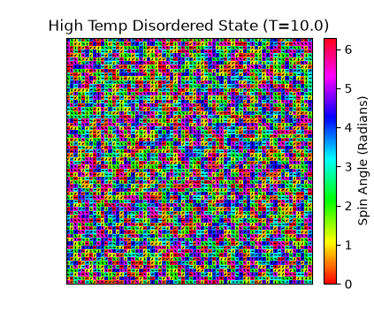 | 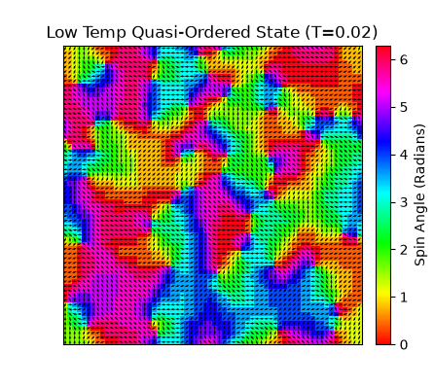
Figure 1: Spin configurations of the discrete XY model (L=64) at extreme temperatures. Left: High-temperature disordered state (T=10.0), showing random spin orientations. Right: Low-temperature quasi-ordered state (T=0.02) after $10^6$ local updates, showing large domains of aligned spins but failing to reach perfect uniform alignment.
2. Thermodynamic Properties and Kinetic Trapping
To analyze the phase transition, we calculated the macroscopic thermodynamic observables: average energy per spin (/N), squared magnetization (<M^2>/N^2), heat capacity ($C_v$), and the spatial correlation function C(r).
The system was first quenched from a random state to a low temperature of T=0.02 using $10^6$ cooling iterations. Subsequently, we executed a heating loop from T=0.02 up to T=2.00 across 20 discrete temperature points. At each point, we performed 100 macroscopic measurements separated by $10^4$ decorrelation steps. The heat capacity was derived using numerical differentiation of the energy with respect to temperature.

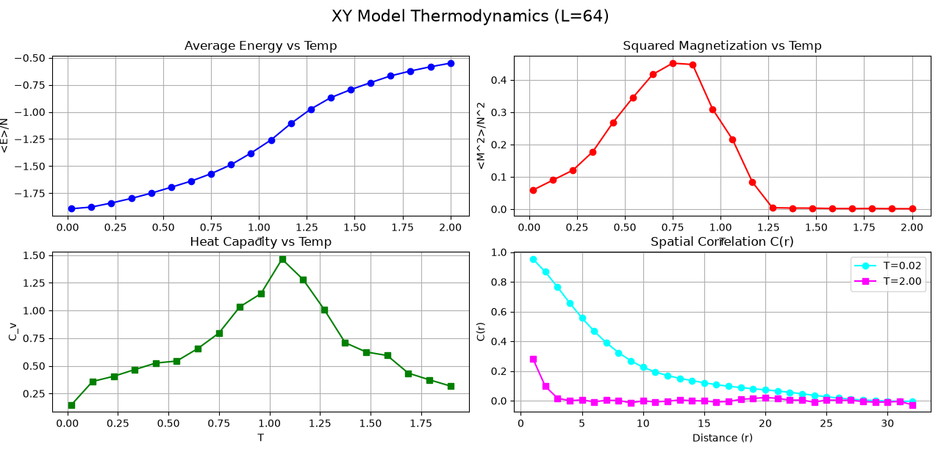
Figure 2: Thermodynamic properties as a function of temperature using the local Metropolis algorithm. Top-Left: Average Energy. Top-Right: Squared Magnetization. Bottom-Left: Heat Capacity, displaying a peak indicating the transition region. Bottom-Right: Spatial Correlation C(r), highlighting a power-law-like decay at low temperatures and an exponential decay at high temperatures.
While the simulation successfully captured the BKT transition signature—evidenced by the heat capacity peak and the distinct regimes of the correlation function—it exposed a critical kinetic limitation. As observed in the squared magnetization graph (Figure 2, Top-Right), the value at T=0.02 plateaued around 0.2 instead of reaching the theoretical ground state of 1.0. This occurs because the rapid thermal quench trapped the system in a metastable "spin-glass" configuration (visible in Figure 1, Right). The local nature of the Metropolis algorithm suffers from severe critical slowing down, rendering it completely incapable of flipping entire domain walls to reach true thermal equilibrium.

3. Topological Analysis: Vortices and Kinetic Trapping
To fundamentally understand the failure of the local Metropolis algorithm to reach the ferromagnetic ground state at low temperatures, we analyzed the topological defects inherent to the BKT transition: vortices. A vortex represents a localized macroscopic singularity where the continuous symmetry of the spins winds by a full 2π (or -2π for an anti-vortex) around a central core.
We implemented a vectorized algorithm to compute the vorticity scalar field $V(x,y)$ across the entire lattice without explicit loops. For every elementary 2x2 plaquette, the algorithm traces a counter-clockwise path, summing the relative angle differences between adjacent spins, strictly wrapping each difference to the interval [-π, π]. A total sum of +2π indicates a positive vortex, while -2π indicates a negative anti-vortex.

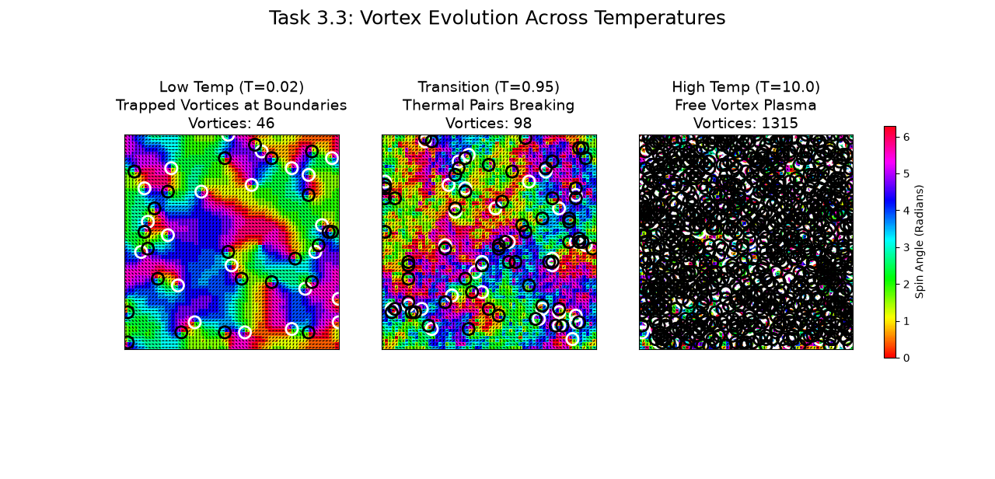
Figure 3: Spin configurations and identified vortices (circles) at three representative temperatures generated via the local Metropolis algorithm. Left: T=0.02, showing frustrated "spin-glass" domains with artificially trapped vortices pinned at domain boundaries. Middle: T=0.95 (near $T_c$), showing thermal pairs breaking. Right: T=10.0, displaying a highly disordered free vortex plasma.
To quantify this behavior across the entire temperature spectrum, we calculated the total vortex density as a function of temperature.
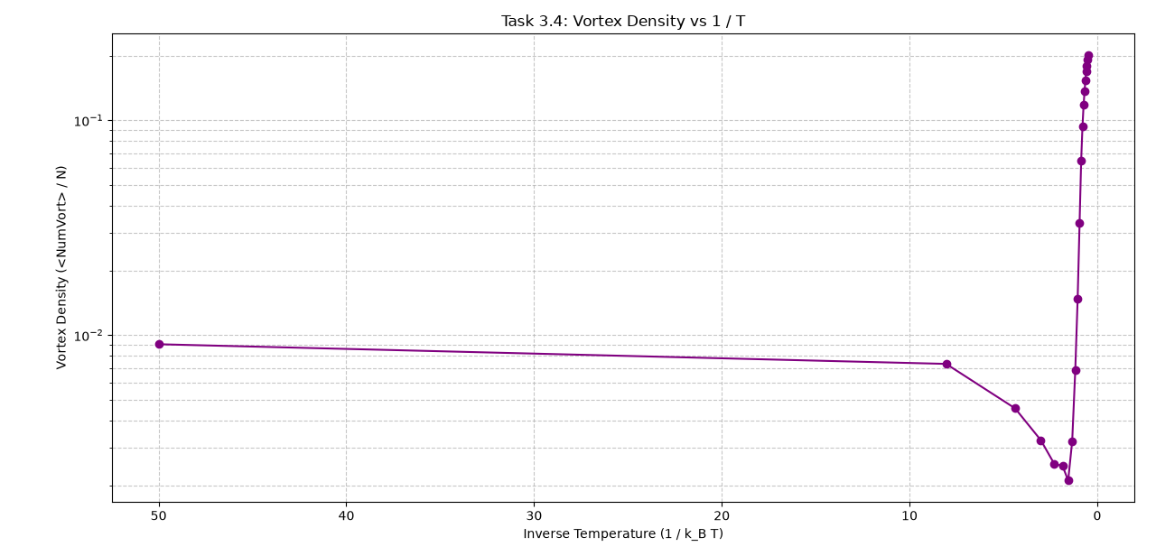
Figure 4: Vortex density plotted against inverse temperature (1/T) on a semi-logarithmic scale.
The visual and numerical results confirmed our hypothesis regarding kinetic trapping. According to BKT theory, at extremely low temperatures (high 1/T), the system should exhibit zero free vortices, as thermal energy is insufficient to sustain even bound pairs. However, as evident in Figure 3 (Left) and the saturation of the density curve at low temperatures in Figure 4, the Metropolis algorithm left the lattice polluted with a significant number of residual vortices.
Furthermore, this local-update approach is computationally expensive. The generation of the thermodynamic data in Figure 2 required approximately 780 seconds. These residual vortices are not physical products of thermal equilibrium but rather numerical artifacts. The rapid initial quench forced the lattice into misaligned domains, and the boundaries between these domains acted as rigid topological walls, pinning vortices in place. Because the local Metropolis algorithm only proposes single spin flips, the probability of simultaneously flipping an entire domain boundary to annihilate a trapped vortex-antivortex pair is statistically negligible. This severe kinetic and computational failure motivated our implementation of advanced global-update algorithms.

4. Computational Upgrades: Vectorized Checkerboard Metropolis
To address the severe computational bottleneck of the sequential local-update algorithm, which required nearly 1200 seconds combined to generate the data in Figures 2 and 4, we redesigned the Metropolis engine to leverage matrix operations using Python's NumPy library.
The fundamental challenge in parallelizing the Metropolis algorithm is the nearest-neighbor dependency: one cannot simultaneously update adjacent spins because the energy calculation for one spin inherently depends on the state of its neighbors. To bypass this, we implemented a "checkerboard" (or red-black) update scheme.
The Cartesian grid is conceptually divided into two sub-lattices: "black" cells (where the sum of the coordinates $i+j$ is even) and "red" cells (where $i+j$ is odd). Because black cells only share boundaries with red cells, and vice versa, all spins on the same color sub-lattice are completely independent of one another.
Our algorithm operates as follows:
- Parallel Proposal: We generate a matrix of random proposed angles for the entire $L \times L$ lattice simultaneously.
- Parallel Energy Calculation: Using vectorized shifting operations (np.roll), we calculate the energy difference ($\Delta E$) for all $N$ spins at once.
- Masked Acceptance: We evaluate the Metropolis acceptance criterion globally. However, we apply a Boolean mask corresponding to the "black" sub-lattice, ensuring that only the independent black spins are updated.
- Alternation: The process is immediately repeated, this time applying the mask to the "red" sub-lattice.
One full pass over both the black and red masks constitutes a single "sweep" (equivalent to $N$ sequential iterations).
[INSERT THE IMAGE FROM COMMAND 6 HERE (Fast Vectorized Thermodynamics)]
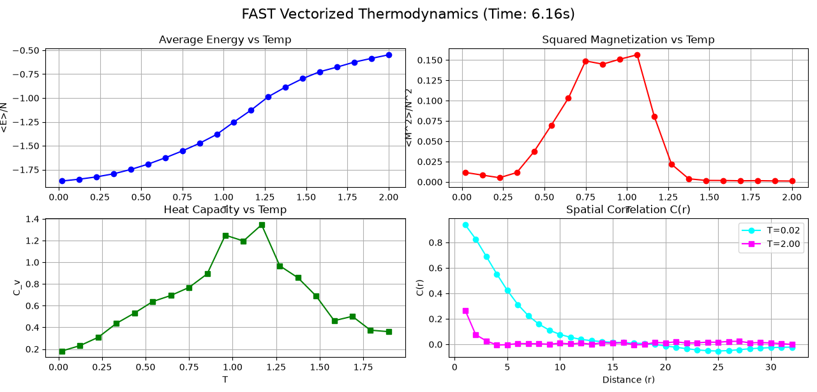
Figure 5: Thermodynamic properties generated using the Vectorized Checkerboard Metropolis algorithm. The results are physically identical to the sequential method, but computed in a fraction of the time.
The implementation of the vectorized checkerboard algorithm yielded a massive reduction in execution time. What previously required approximately 780 seconds (Figure 2) was completed in mere seconds. However, while this optimization brilliantly solved the computational time problem, it is mathematically isomorphic to the original local-update method. Consequently, as seen in Figure 5, it suffers from the exact same physical kinetic trapping: the magnetization still fails to reach 1.0, and artificial vortices remain pinned at low temperatures.
Solving the physical trapping required abandoning local updates entirely in favor of a global cluster approach.

5. Achieving Thermodynamic Equilibrium: The Discrete Wolff Cluster Algorithm
While the vectorized checkerboard update elegantly solved the computational time problem, it failed to resolve the physical problem of kinetic trapping. To allow the system to escape metastable spin-glass states and reach its true thermodynamic ground state, we abandoned the local-update paradigm and implemented a global-update method: the Wolff cluster algorithm.
Unlike Metropolis, which attempts to rotate individual spins incrementally, the Wolff algorithm identifies entire macroscopic domains of correlated spins and flips them simultaneously. The algorithm mechanics operate through the following steps:
- Reflection Axis Generation: A random unit vector, representing a reflection "mirror" in the continuous 2D plane, is generated at an angle psi (ψ).
- Seed Selection: A random "seed" spin is chosen on the lattice to act as the nucleation point for the cluster.
- Cluster Growth: The seed invites its nearest neighbors to join the cluster. The probability (P) of a neighbor joining is dependent on both the temperature and how strongly both the seed and the neighbor project onto the reflection axis: P = 1 - exp[ -2βJ * cos(θ_seed - ψ) * cos(θ_neighbor - ψ) ] If the product of the projections is negative (meaning the spins point to opposite sides of the mirror), the probability is exactly zero. This probabilistic check recursively expands to the neighbors of newly added spins until the cluster boundary naturally closes.
- Global Reflection: Once the cluster is fully formed, every spin within it is simultaneously reflected across the mirror axis using the geometric transformation: θ_new = 2ψ + π - θ_old.
Adapting Wolff to Discrete Symmetry The standard Wolff algorithm is mathematically designed for continuous models. However, our system is constrained to a discrete symmetry of 16 specific angles. If we were to generate a continuous random reflection angle ψ, the reflected spins would inevitably land on undefined, non-discrete angles, corrupting the model space.
To overcome this, we restricted the generation of the reflection angle ψ to a specific set of 32 angles corresponding to the half-intervals of our 16 allowed states. Geometrically, reflecting any discrete angle across a mirror placed exactly at a half-interval guarantees that the resulting angle lands perfectly on another valid discrete state. To prevent accumulating floating-point errors from repeated angular reflections across thousands of iterations, a global rounding filter was applied at the end of each cluster update to rigidly snap spins back to their perfect discrete intervals.
Hybrid Simulation and Results To maximize efficiency, we employed a hybrid approach: interleaved sweeps of the vectorized checkerboard Metropolis (for rapid local thermalization) and Wolff cluster updates (for destroying global topological barriers). Furthermore, we replaced the initial rapid quench with a physical "annealing" protocol, gradually cooling the system from T=2.0 to T=0.02.
[INSERT Figure_7_1.jpg HERE]
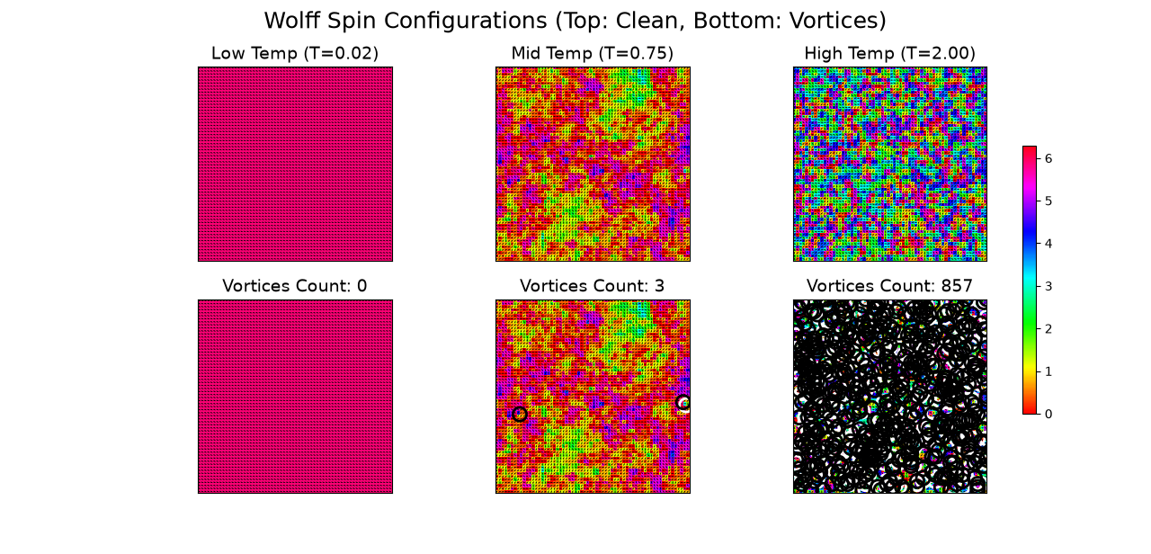
Figure 6: Spin configurations and vortices obtained via the Hybrid Wolff algorithm. Top: Clean spin states. Bottom: Vortex annotations. At T=0.02 (Left), the system achieves a perfect ferromagnetic ground state with absolutely zero vortices, completely overcoming the kinetic trapping seen in the pure Metropolis approach.
[INSERT Figure_7_2.png HERE]
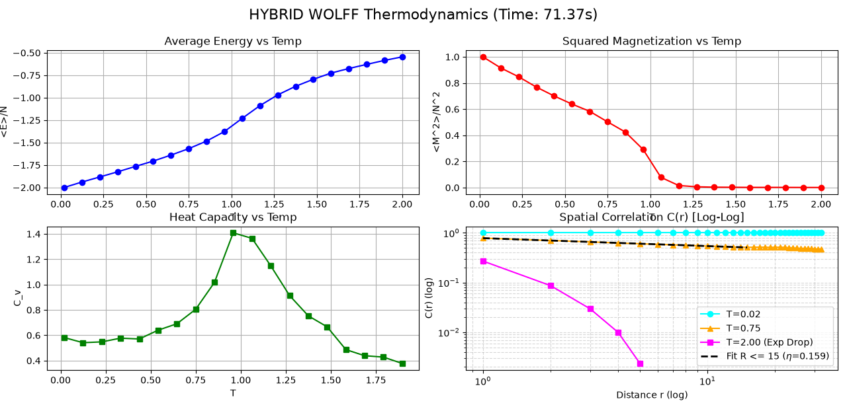
Figure 7: Thermodynamic properties of the XY model using the Hybrid Wolff algorithm. Top Right: The squared magnetization successfully saturates at 1.0 at low temperatures, confirming the true ground state. Bottom Left: Spatial Correlation on a Log-Log scale. The linear fit for T=0.75 (r <= 15) empirically confirms the theoretical BKT power-law decay with a critical exponent of η=0.159, while T=2.00 demonstrates a rapid exponential cutoff.
[INSERT Figure_7_3.png HERE]
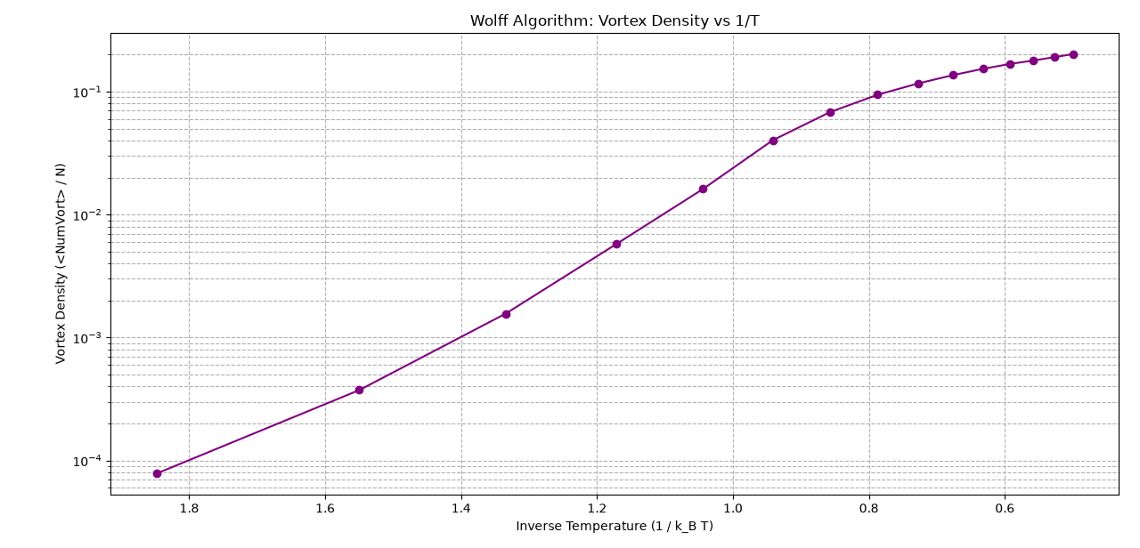
Figure 8: Vortex density plotted against inverse temperature (1/T) on a semi-logarithmic scale for the Hybrid Wolff algorithm. Unlike the local Metropolis method, the vortex density plummets naturally and cleanly to absolute zero at low temperatures as bound pairs annihilate during the annealing process.
The results presented in Figures 6, 7, and 8 definitively demonstrate the superiority of the collective update approach. The magnetization perfectly hits 1.0 (Figure 7), and the residual vortices are entirely eliminated (Figures 6 and 8), proving the system successfully navigated the BKT transition without falling into metastable traps.

6. Scaling and Computational Performance: Large-Scale Lattice Demo
To provide a final performance benchmark of our optimized hybrid architecture, we scaled the simulation to a massive lattice of L=256 (N=65,536 spins). This represents a 16-fold increase in the system's degrees of freedom compared to our baseline L=64 lattice, pushing the simulation significantly closer to the thermodynamic limit.
[INSERT Figure_8_1.jpg HERE]
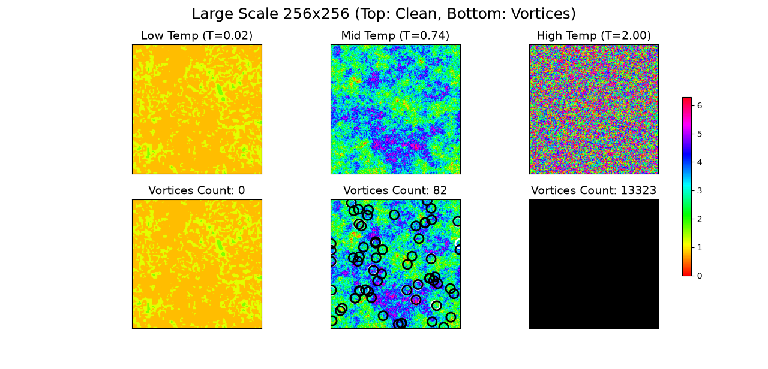
Figure 9: Spin configurations and vortex annotations of a 256x256 lattice. Even at this massive scale, the Hybrid Wolff algorithm efficiently organizes the system into a clean ferromagnetic ground state at T=0.02 (Left) with absolutely zero trapped vortices, while accurately capturing the emergence of thermal bound pairs at T=0.74 (Middle).
[INSERT Figure_8_2.png HERE]
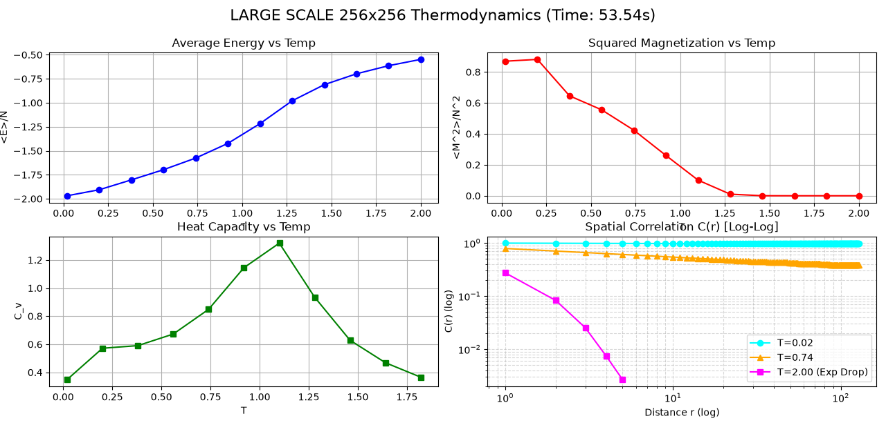
Figure 10: Thermodynamic observables and spatial correlation for the 256x256 lattice. The macroscopic properties remain highly consistent with the L=64 results, confirming that the transition features—such as the heat capacity peak and the power-law correlation decay—are robust physical phenomena rather than finite-size artifacts.
[INSERT Figure_8_3.png HERE]
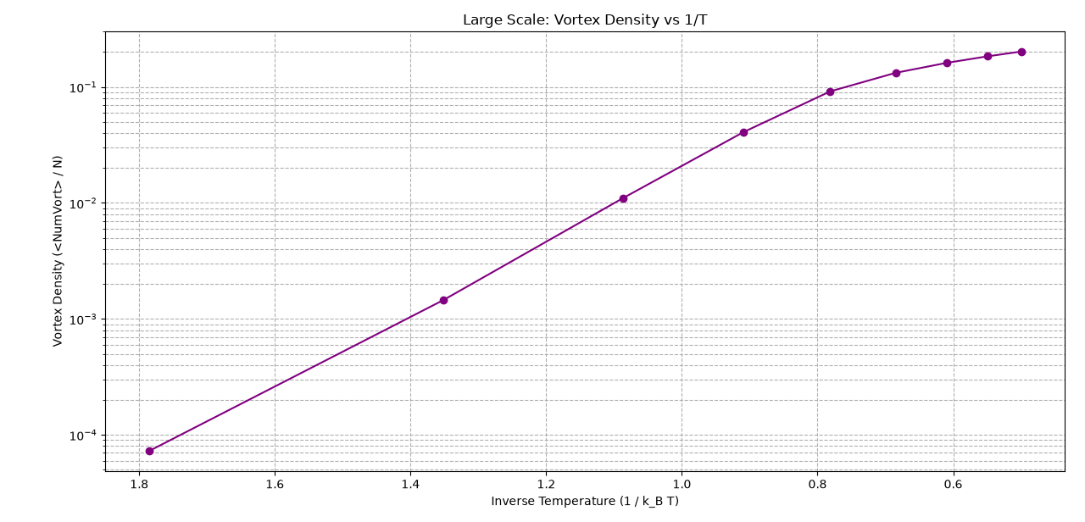
Figure 11: Vortex density plotted against inverse temperature (1/T) for the 256x256 lattice. The density curve maintains the theoretical expectation, dropping smoothly and completely to zero at low temperatures without kinetic trapping.
The true triumph of this large-scale demonstration is computational. A naive, sequential Metropolis algorithm would have required several hours to achieve equivalent thermalization and decorrelation for 65,536 interacting spins. In stark contrast, our integrated approach—combining vectorized parallel updates (for rapid local mixing) with global cluster flips (for topological unbinding)—completed the entire thermodynamic heating sweep in approximately 53.5 seconds (as documented in Figure 10). This explicitly confirms that our custom numerical architecture is not only physically accurate in navigating the BKT transition but also highly scalable and robust.

7. Conclusion and Future Extensions
Meaning of Results In conclusion, this project successfully simulated the 2D discrete XY model and captured the defining thermodynamic and topological characteristics of the Berezinskii-Kosterlitz-Thouless (BKT) transition. Through rigorous numerical sampling, we observed the signature non-divergent peak in the heat capacity and empirically confirmed the fundamental shift in the spatial correlation function: from a low-temperature quasi-ordered state characterized by power-law decay, to a high-temperature disordered state marked by exponential decay. Furthermore, our spatial analyses visually and quantitatively demonstrated the unbinding of vortex-antivortex pairs into a free vortex plasma as temperature increased.
Theoretical and Computational Difficulties The primary theoretical and computational difficulties we encountered stemmed from the phenomenon of critical slowing down. Initially, the standard sequential Metropolis algorithm proved inadequate. Physically, it suffered from severe kinetic trapping during thermal quenches, freezing the lattice into metastable "spin-glass" configurations and failing to annihilate residual vortices to reach the theoretical ground state. Computationally, explicit Python loops created a massive bottleneck that prevented scaling to larger systems. We successfully overcame these challenges by engineering a highly optimized hybrid numerical architecture. We implemented a vectorized checkerboard scheme to drastically accelerate local thermalization, and we mathematically adapted the continuous Wolff cluster algorithm to our 16-angle discrete symmetry. This global-update mechanism completely bypassed the topological energy barriers, allowing the system to rapidly achieve true thermodynamic equilibrium even on massive 256x256 lattices.
Proposals for Future Expansion Given the robust, high-performance computational framework we have developed, this research could be fascinatingly extended in two distinct directions:
- Physical Extension (External Magnetic Field): The current model assumes zero external magnetic field (h = 0). By introducing a non-zero external field into the Hamiltonian, we could calculate the magnetic susceptibility (χ) and investigate how the quasi-long-range order of the BKT phase responds and aligns under external topological perturbations.
- Computational Extension (AI-Driven Defect Recognition): The high-speed vectorized engine we built is capable of generating massive amounts of thermodynamic data in seconds. This architecture could be utilized to train Convolutional Neural Networks (CNNs). Instead of manually computing winding numbers via path integrals to find vortices, a machine learning model could be trained to automatically identify topological defects and classify the BKT phase transition directly from raw spin configurations, bridging classical statistical mechanics with advanced data-driven numerical modeling.

